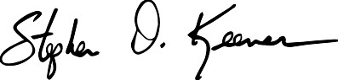
Stephen D. Keener
President and Chief Executive Officer

Dear Little League® President,

It is my pleasure to present your league with its Certificate of Charter for the 2021 Little League® season. Your acceptance of this charter is a pledge to operate your league in compliance with the terms of this charter and provide a healthy, recreational activity to a new group of families and Little Leaguers® this year.

Since 1939, millions of dedicated volunteers around the world have provided the benefits of the Little League program to children in their communities. Little League adult volunteers are entrusted with the responsibilities of developing a fun, well-organized, and healthy environment that supports the social and emotional learning that takes place both on and off the field of play under the Little League banner.

Through the sports of baseball and softball, Little League helps prepare children for life through the lessons learned on a playing field. Little League is about more than baseball or softball, it emphasizes the attributes of teamwork, sportsmanship, and self-discipline. We trust that you and your league’s volunteer leaders understand you’re a critically important role in developing tomorrow’s leaders.

We thank you, the volunteers in your league, and your community for appreciating the benefits of chartering with Little League Baseball and Softball and wish you all the best for a memorable and fun 2021 season.
Sincerely,

STEPHEN D. KEENER
President and Chief Executive Officer Little League® Baseball and Softball

Enclosure: 2021 Little League Certificate of Charter

2021
Little League® Certificate of Charter
This Certifies that

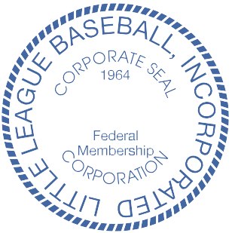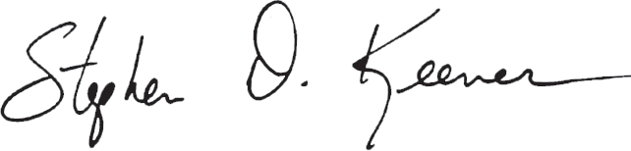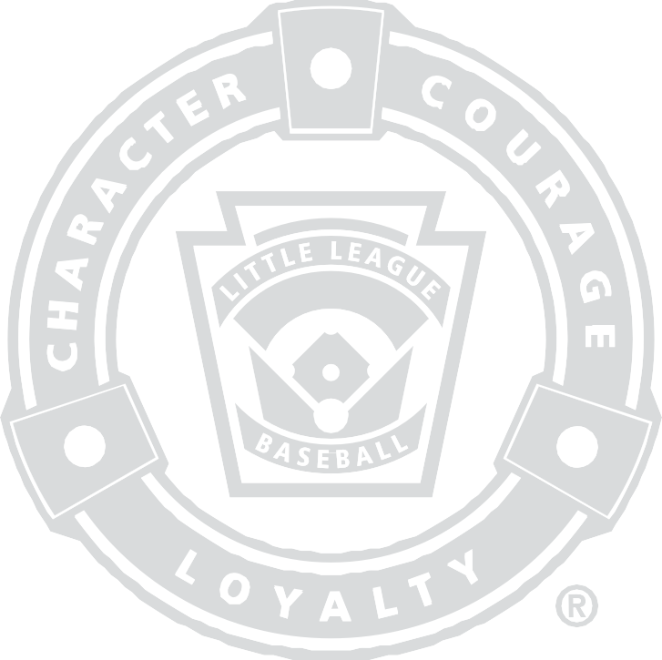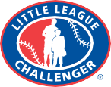

Rock Island-Milan American Little League

has been organized as a Chartered program
in accordance with established procedures of Little League Baseball, Incorporated and is hereby franchised for 2021. Granted herein are all privileges needed for proper conduct of your League consistent with the best interest of the Little League movement.

Issued January 1, 2021 at Williamsport, Pennsylvania

This Charter expires
December 31, 2021

President and Chief Executive Ojficer

